37.23: 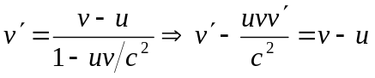
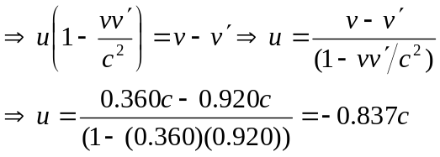
 moving opposite the rocket, i.e., away from Arrakis.

